File Permissions

Types of File Permissions
Linux file permissions are critical for system security and proper file sharing. There are three main types of file permissions:
• Basic Permissions: Read, write, and execute.
• Special Permissions: Setuid, setgid, and sticky bit, which grant special privileges.
• Access Control List (ACL): Provides more fine-grained permissions for individual users or groups.

Permission Values
Permissions are represented by numeric values:
• Read (r): Value 4. Allows viewing a file's contents or listing a directory's contents.
• Write (w): Value 2. Allows modifying a file or creating/deleting files within a directory.
• Execute (x): Value 1. Allows running a script or accessing a directory.

User Categories
Permissions are defined for three categories of users:
• User (u): The owner of the file.
• Group (g): Users who belong to the file's group.
• Others (o): All other users on the system.

umask
The user file creation mode mask (umask) determines the default file permissions for newly created files and directories. It acts as a filter, masking out permission bits so that the final permissions are more restrictive than the system-wide defaults.
When a new file or directory is created, the operating system starts with a set of base permissions:
• Files: 666 (read and write for owner, group, and others; no execute by default)
• Directories: 777 (read, write, and execute for owner, group, and others)
The umask value is subtracted from these base permissions to determine the final permissions.
Default umask value is 0022
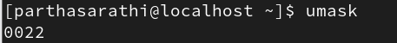
To change umask value permenantly for everyone use
#vi /etc/login.defs
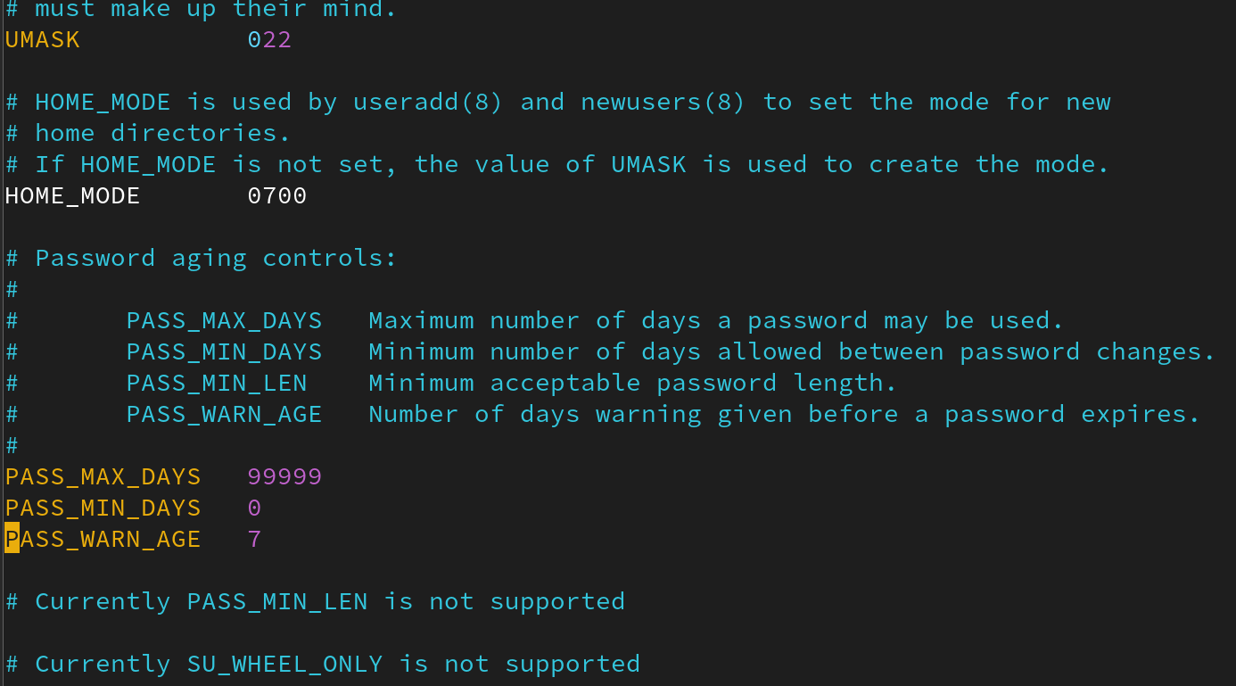
To change unmask value temperory
#umask (what permissions you want to give)
It will work until you reboot
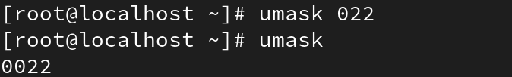

Methods to Set Permissions
Permissions can be set using:
• Octal (Numeric) Method: Uses a three-digit number representing permissions for user, group, and others. Example: 755 means rwx for user, rx for group and others.
• Symbolic Method: Uses letters (r, w, x) and symbols (+, -, =) to add, remove, or set permissions. Example: u+rwx adds read, write, execute to the user; g-w removes write from the group.

Setting File and Directory Permissions in Linux
We can set permissions for files and directories in Linux using two methods:
- 1. Octal or Numeric Method (e.g., 421)
- 2. Symbolic Method (e.g., rwx)

Permission Values
Each permission has a specific numeric value:
• Read (r) = 4
• Write (w) = 2
• Execute (x) = 1
Example: rw rx wx = 6 5 3

1. Numeric (Octal) Method
In this method, permissions are represented using numbers that are the sum of the permission values:
# chmod 744 <file/directory> -> Owner: read, write, execute (7); Group: read (4); Others: read (4)

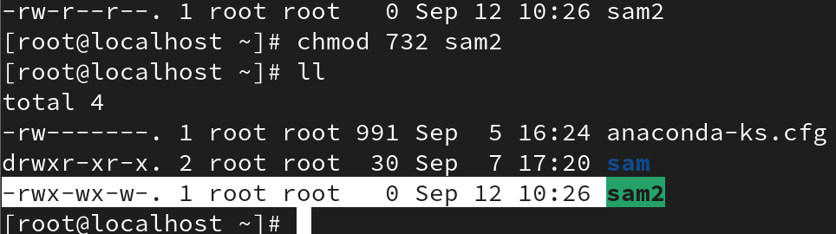

2. Symbolic Method
In this method, permissions are changed using letters to represent users and permissions:
# chmod u=rwx,g=rw,o=r <file/directory> -> User: read, write, execute; Group: read, write; Others: read
It overwrites the permissions.

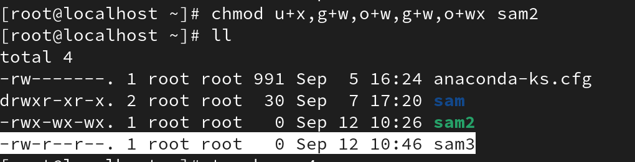
# chmod u+x,g+rw,o+r <file/directory>
Its add permission to already existing one

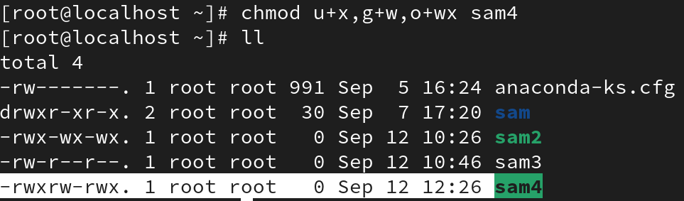
#chmod u-r,g-x,o-w <username>
It removes the permission

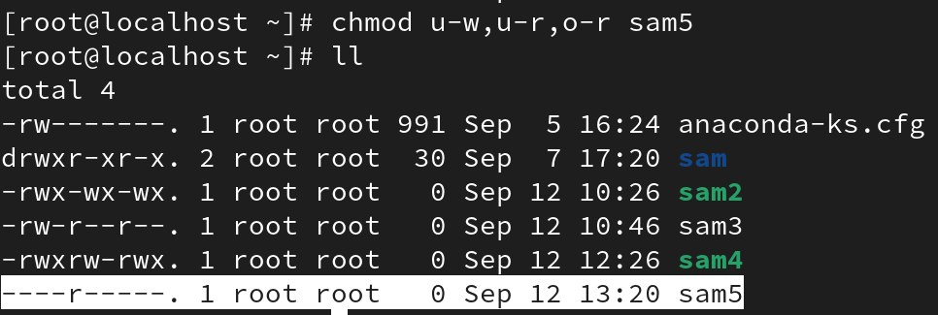
# chmod a=rwx testfile1 -> Give read, write, execute to all (user, group, others)
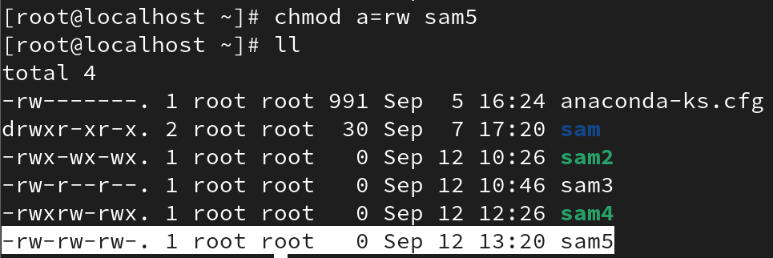
+ → add permission
- → remove permission
= → set exact permission (replace existing)

Commands for Managing Permissions and Ownership
Key commands to manage permissions and ownership include:
• ls -l: Displays file permissions, ownership, and other details.
• umask: Shows or sets the default permission mask for new files and directories. Default is typically 0022.
• chmod: Changes file and directory permissions.
- Numeric: chmod 644 <filename>
- Symbolic: chmod u=rwx,g=rw,o=r <filename>
• chown: Changes file/directory ownership.
- chown <username> <filename>

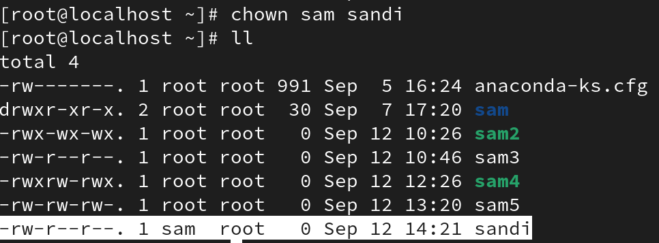
- chown -R <username> <filename> (to change recursive file)
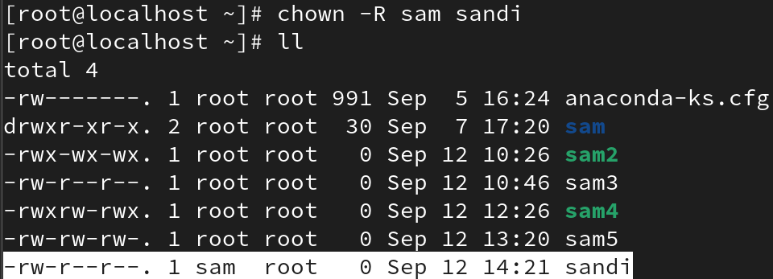
• chgrp: Changes the group ownership of a file or directory.
- chgrp <groupname> <filename>

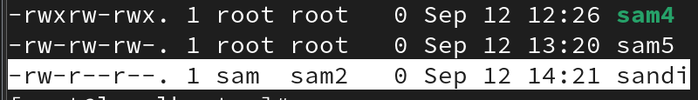
#chown :
It can also change group

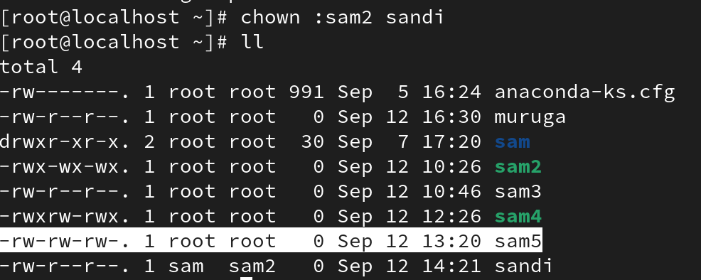

Default Permissions
Default permissions vary by context:
• Default directory permissions: 777 (read, write, execute for all).
• Default file permissions: 666 (read and write for all, no execute).
• Default permissions for / (root filesystem): 555 (read and execute for all).
• Default permissions for /root directory: 550 (owner read/execute, group read/execute).
• Default permissions for /home: 700 (owner full access, no access for others).
• Default permissions for /var/spool/mail: 660 (owner and group read/write).

